
Name = Muhammad Daniyal
Registration no = 24371
Datye : 22/06/2026
Teacher : Mam Faryal
Lab 13
Operator Overloading
Lab Tasks
Task 1:
- Add a member function display() in the Complex class.
- Use this function to print complex numbers instead of printing directly in main().
INPUT/OUTPUT:

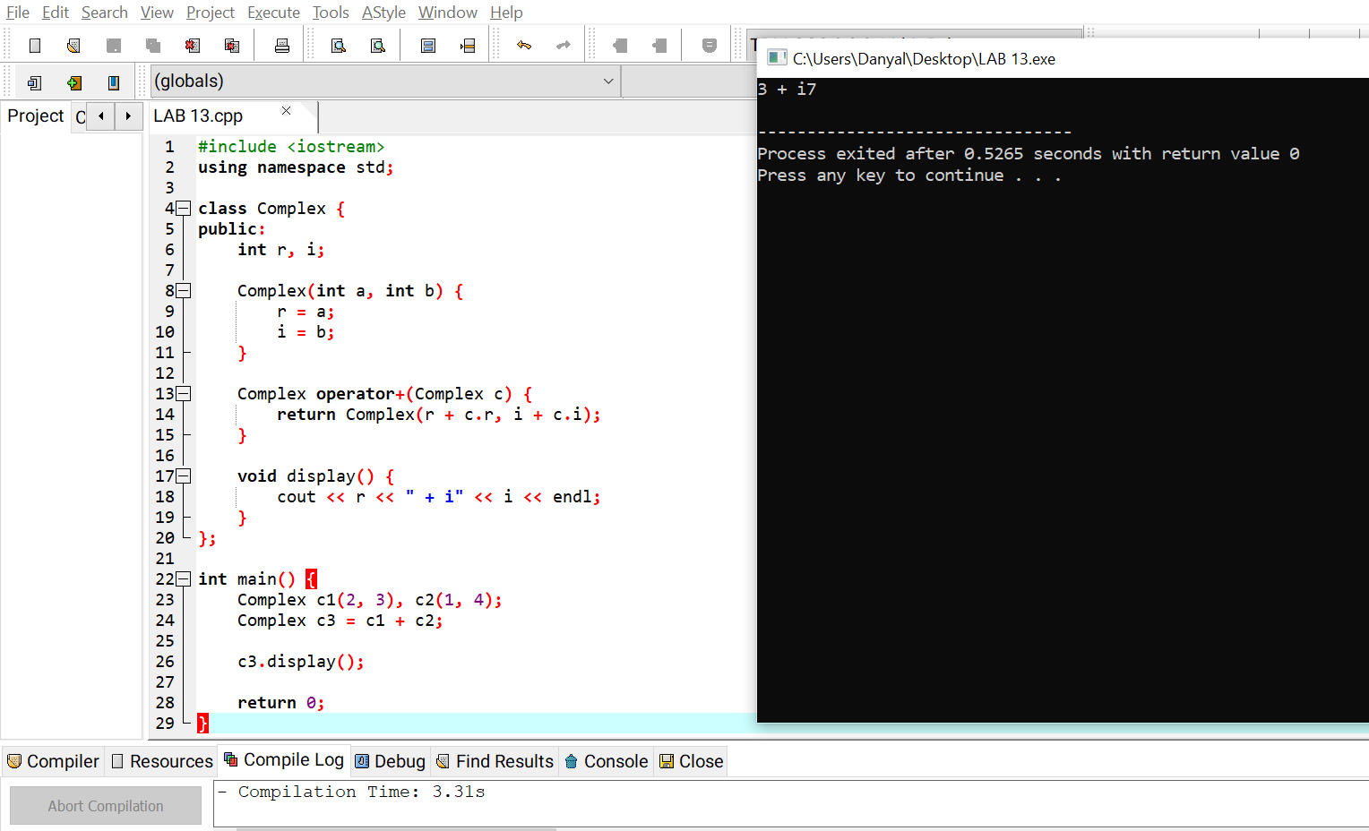

Task 2:
- Overload the minus (-) operator to subtract two complex numbers.
- Test the operator by subtracting two objects and displaying the result.

INPUT/OUTPUT:
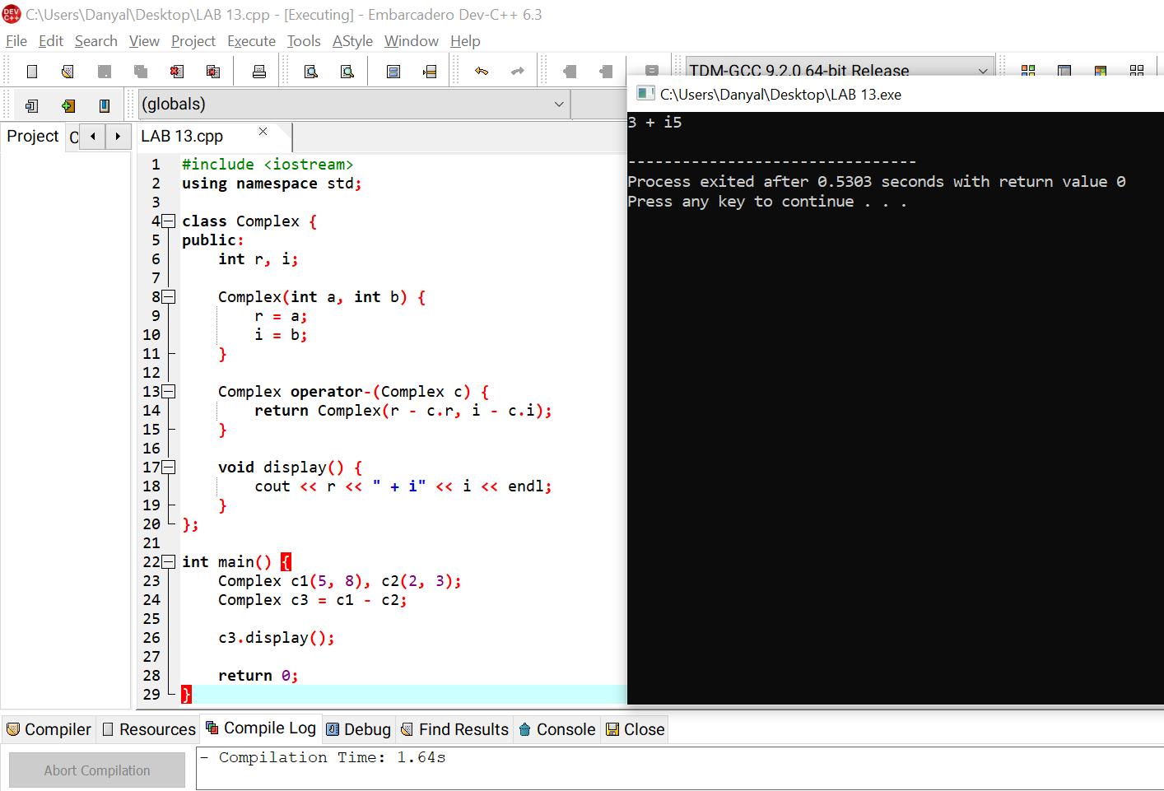

Task 3:
- Modify the program to take real and imaginary parts of complex numbers from the user.
- Perform addition using the overloaded + operator.

GitHub Commands:
git add lab13-operator-overloading.cpp
git commit -m "Lab 13 Operator Overloading" git push

INPUT/OUTPUT:
